Harmeet Bharj

M00712730

Aleksandrs Lukjanovs

M00674847

Dhrumin Prashant Patel

M00734249

Website report

Contents

Introduction 2

Description 3

Overall Performance 4

Planning 5

Screenshot of the front-end website 6

Mongo Database 8

Security Issues 9

# Introduction

In this document I will be going through the process of how we have made an e-commerce website that sells guitars. This coursework is a group exercise and we each had our certain roles to play to finish the website. This report will show how well we worked together and show screenshots and the extensive planning that went into making this website that we have designed.



## Description

The aim of this task was to make an e-commerce website that sells products. The task would have to be done in a group form so we had to split up the work load so everyone would participate. The website we had to build had to have 10-20 products we decided to sell 15 unique products. The website had to be coded with HTML, CSS and JavaScript. The customer would also be allowed to add items to the basket and also buy certain amount of goods. When the customer buys a product, the website would inform the customer with a message that there order has been placed. We would also allow the customer to log back into their account and view their pervious order and recommendations. We would store the data on a server called Mongo DB.

We also have also kept a clean layout with a header and footer. The specific colours that we have used to design this website is blue and white that would match the unique products that we are selling. We have also enlarged the text and all the buttons to make it easy for the user to read our website. This makes the website simple and intuitive to use. The specific products that we are selling are Bass Guitars, Acoustic Guitars, Electric Guitars and many more vintage products that you can find on the shopping page.

# Overall Performance

Overall, I feel the performance was very good and we planned well to make this website as perfect as it could be. We did this by making a sperate group chat on a different platform and we had regular meetings between the three of us and discussed how are we doing and if we needed any help. We would tend to share our screens to see the progress that each member has made, if we were struggling, we would get together and solve the problem together. We also created a bitbucket repository to hand in our work and evaluate when we would finish each task. We also have a spreadsheet that we would fill in to complete the relevant tasks if the task was done, we would highlight it in green, amber would be used if the task is nearing to complete and red is when we are struggling. This method really helped in the making and the overall performance of the group.

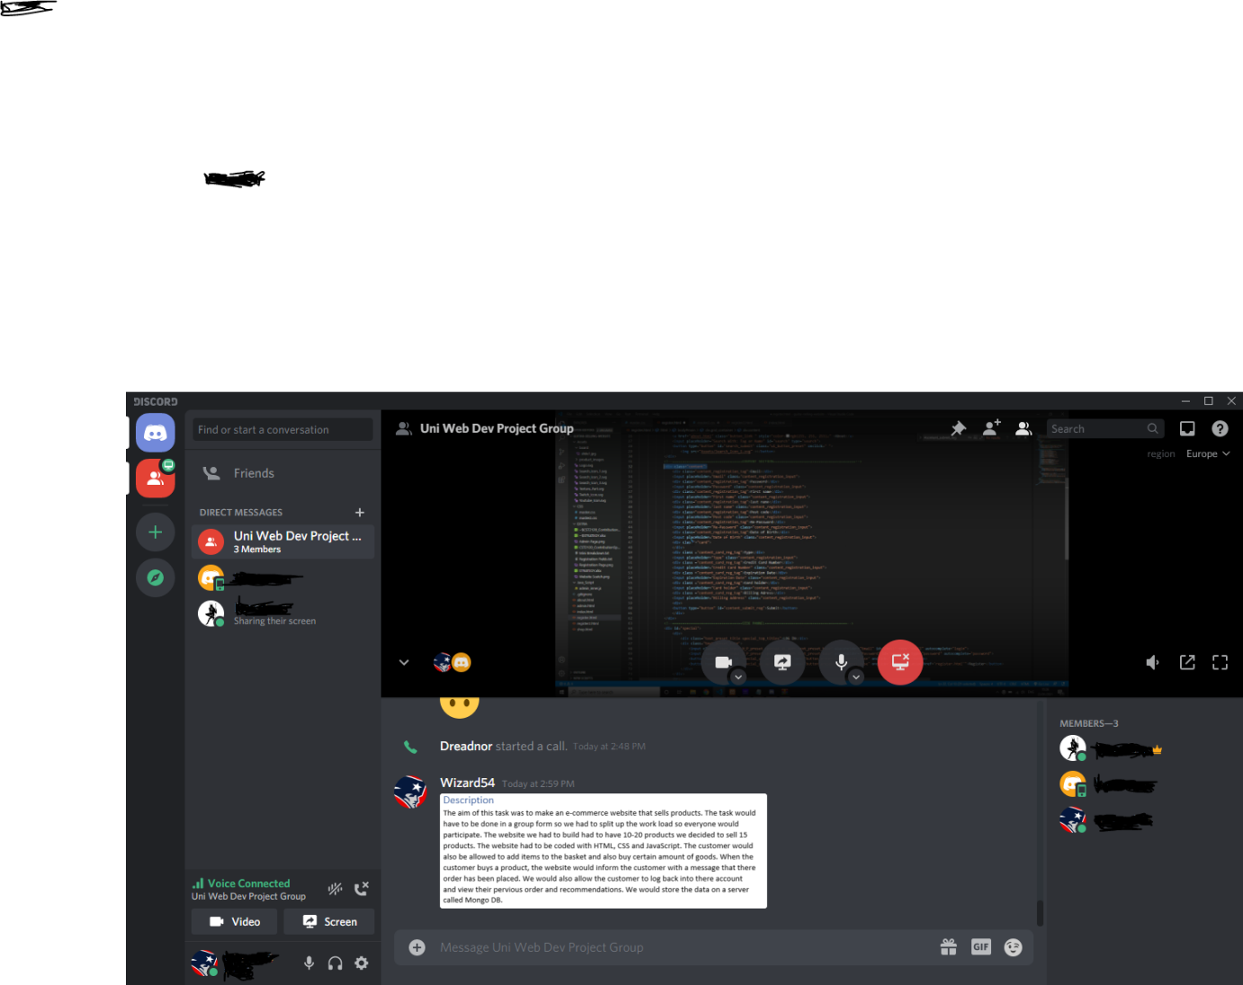Below is an image of an image sharing our screen helping each other in discord.

# Planning

A lot of planning went into making this e-commerce website. Some of the planning that were helpful in designing our e-commerce was we drew an outline of each page and we had to implement in visual studio code. We also used a bit bucket repository to mark all the commits that we have added to the code, whenever we have finished a task, we would put that specific task in the bit bucket repository.

After the first submission we decided to have a group discussion of what we could improve. We decided to make a check list on notepad for thing we could improve in the website. This was very helpful in improving our website when we would finish a specific task, we would type a character to indicate we have finished.

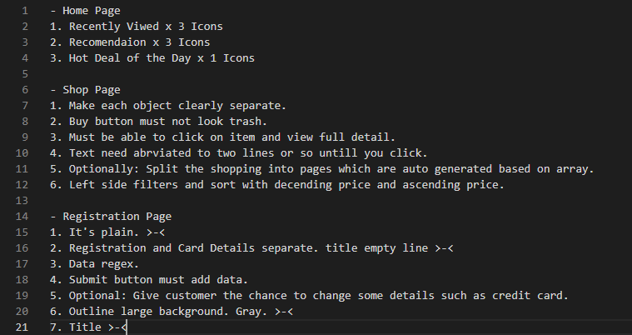Below are some images of our stages of planning.

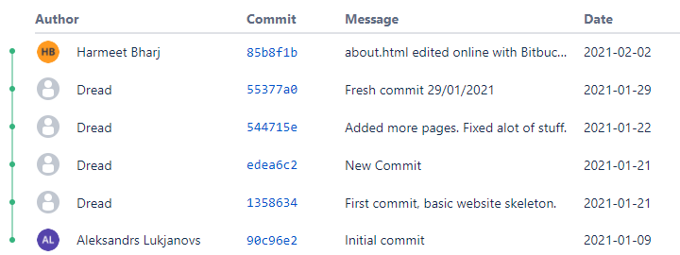

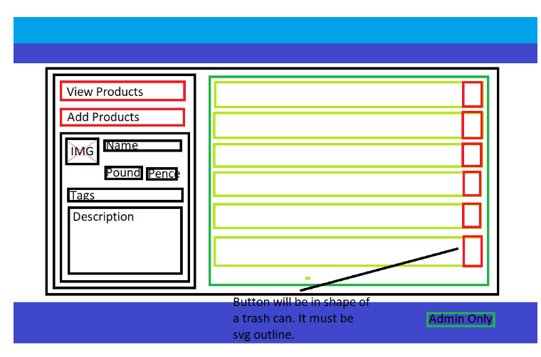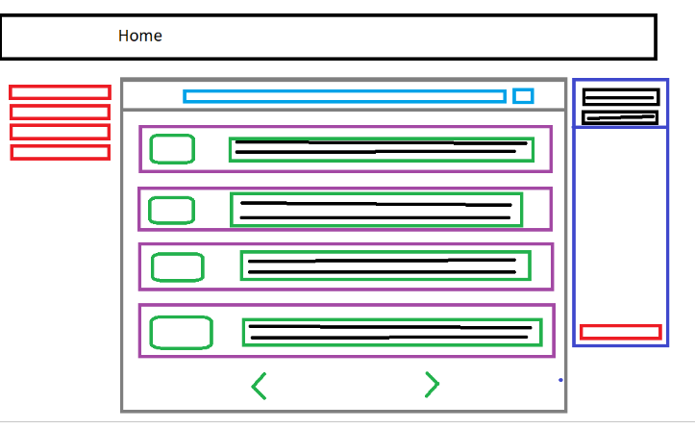

# Screenshot of the front-end website

Below are some screenshots of our fully functionable web page.

Homepage

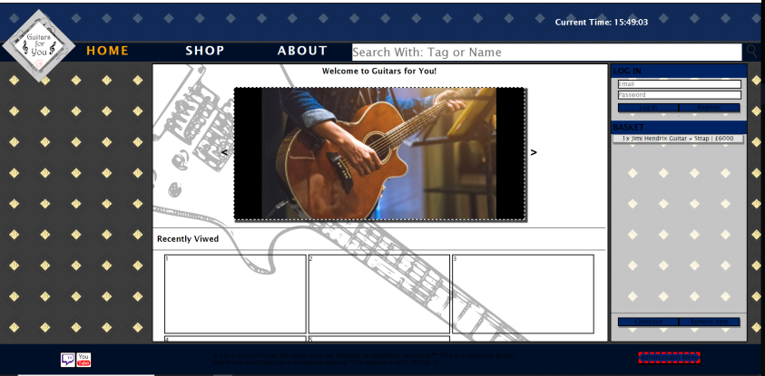

Shopping page

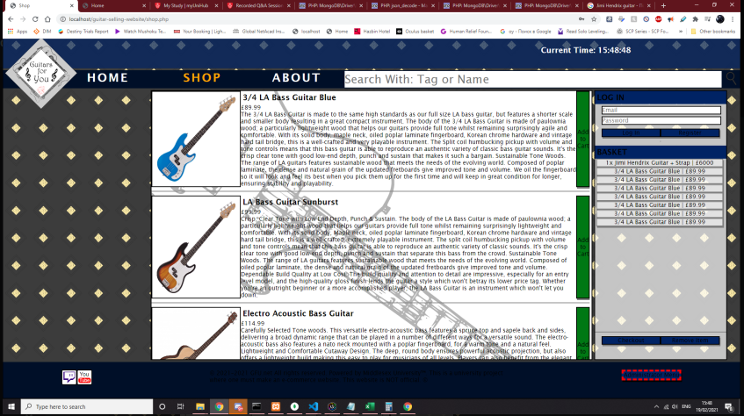

Registration Page

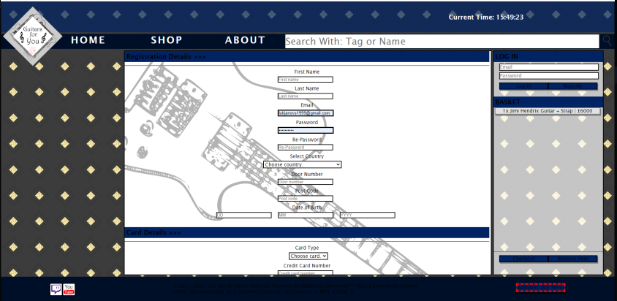

# 

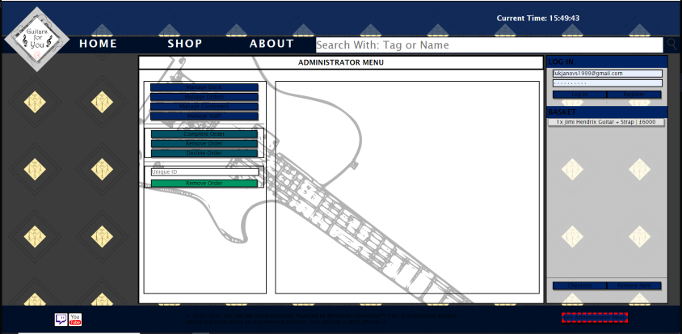

Administrator menu page

# 

About page

# 

# Mongo Database

Below are some screenshots of or Mongo Database.

# 

# 

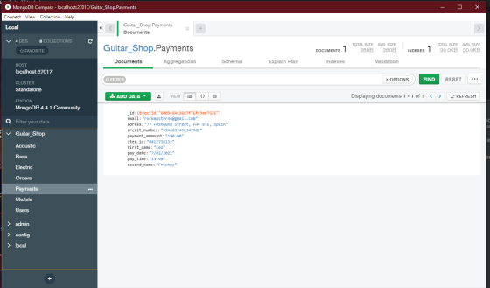

# 

# 

# Security Issues

There are many security issues in todays society. There are some security issues however in our e-commers website that we have made an example of a security issue that we have in our website is when the user adds a password it can be as many letters as they chose. This is an issue as we should give a reminder to the user that they should use at least one number and one symbol to make there password more secure.

Another security issue that we currently have in our e-commers website is on our registration page we have a field called country and the user could easily write the wrong country and our website would not check if they are telling the truth. In this case we could have added a country verification to check if the user is actually telling the truth they are in the same country that they have selected.

Another security issues that is problem in our e-commerce website is for our email field. When the user enters an email, it does not check if the email is valid and correct. To fix this issue we could have added email verification in our website to check if the email is correct. This is a real problem and a very big security issue that is in our website.

An additional security issue that is a problem in our e-commerce website is any customer will be able to use the administration menu page link that we have created for specifically administrators only. This is a very big issue that is in our website as anybody would be able to access our website database and change the products or even hack our information that we have gathered on our customers that is stored in our database. We could have solved this issue by adding more security encryption to our website and having a padlock. This would mean you would be provided with special information to have access to be able to unlock the administrator page.

An additional security issue that is a problem in our e-commerce website is the postcode field and the user will be able to add a random generated postcode and our website would accept this postcode. This is a huge security issue because we as administrators would not know if this postcode is fake or real when we ship the items to the customer. To counter these issues, we would have to write a security encryption to check if the postcode is valid.

A further security issue that is a problem in our e-commerce website if a user were to delete all the information from our database along with all our customer details and our website. This would be a very big security issue as we would lose a lot of customers as well as all of the customer details would have disappeared. To resolve this issue, we would need a backup file of the website and also a backup of our database to get all the resources back up and running.

